Assignment 2:Change ddl statements.
Add roll no before create table, Insert, Delete, update, statement

1]CREATE TABLE:
goto psql source directory
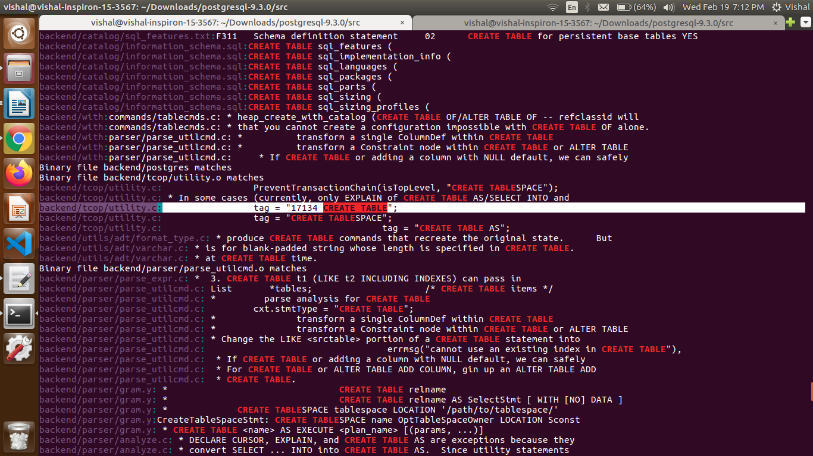
open terminal and type grep -r “CREATE TABLE”
Now open file backend/tcop/utility.c in gedit.
Inside this function const char *
CreateCommandTag(Node *parsetree)
change CREATE TABLE->17134 CREATE TABLE

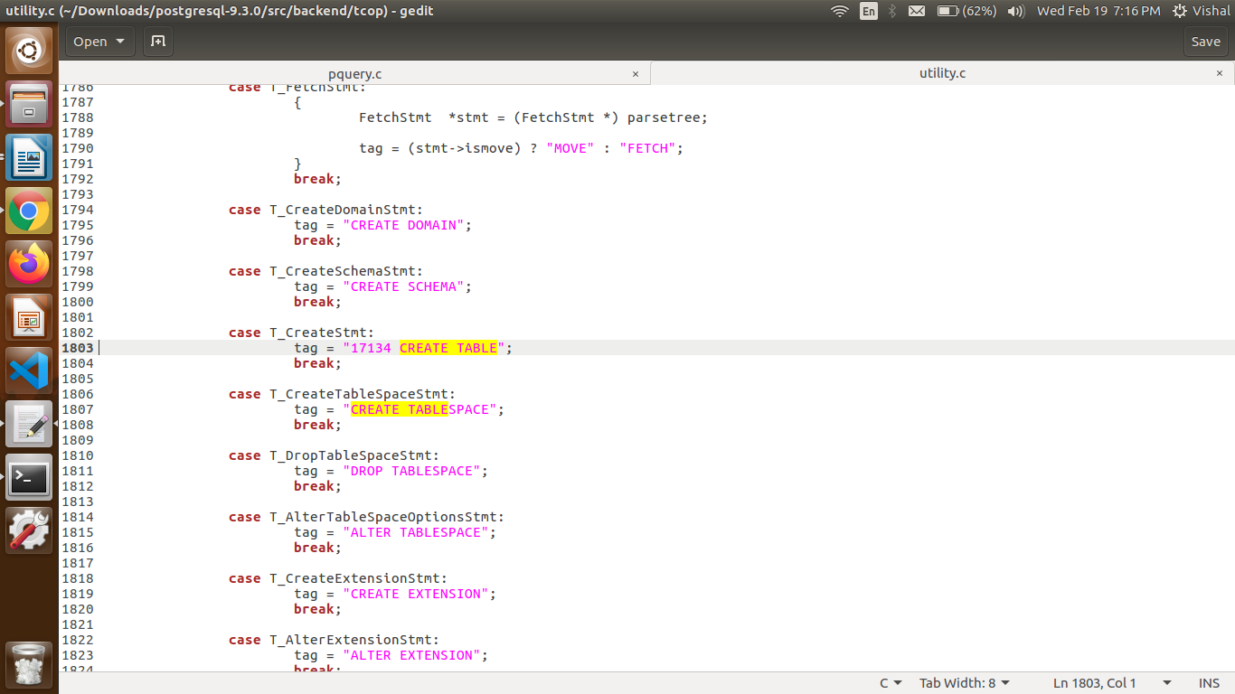
Reinstall the postgres.
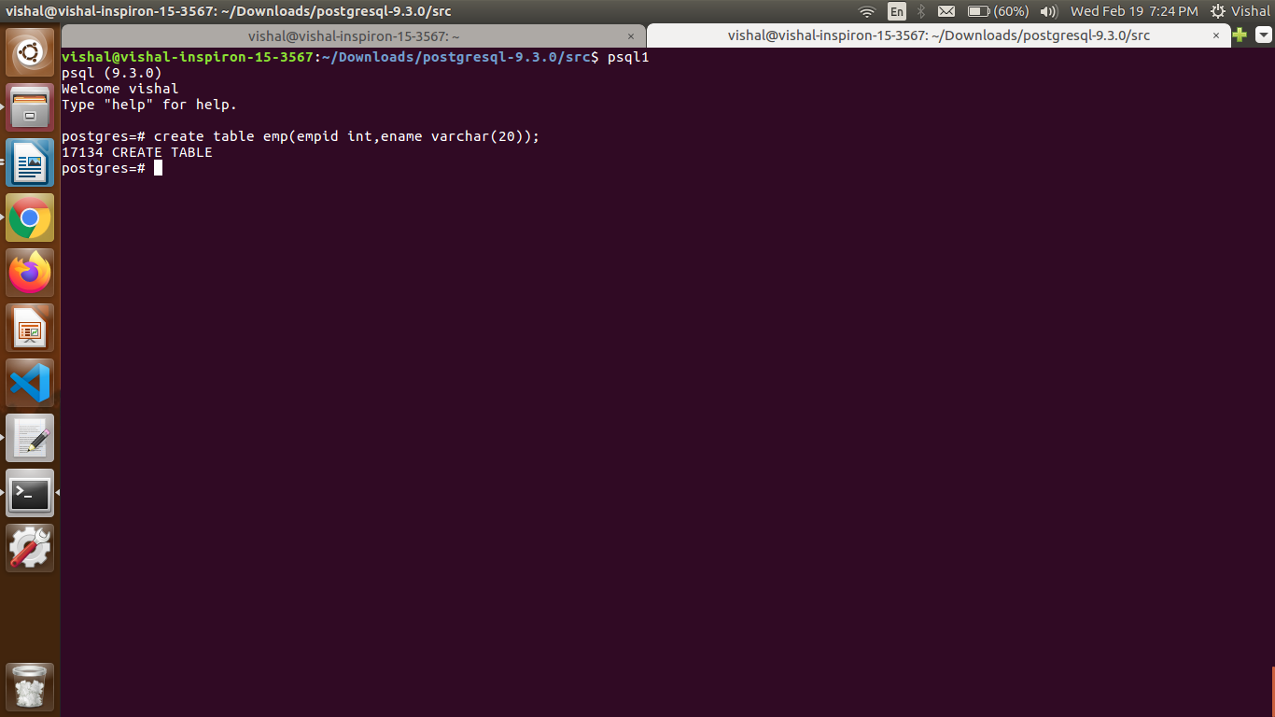
2]After Insert statement

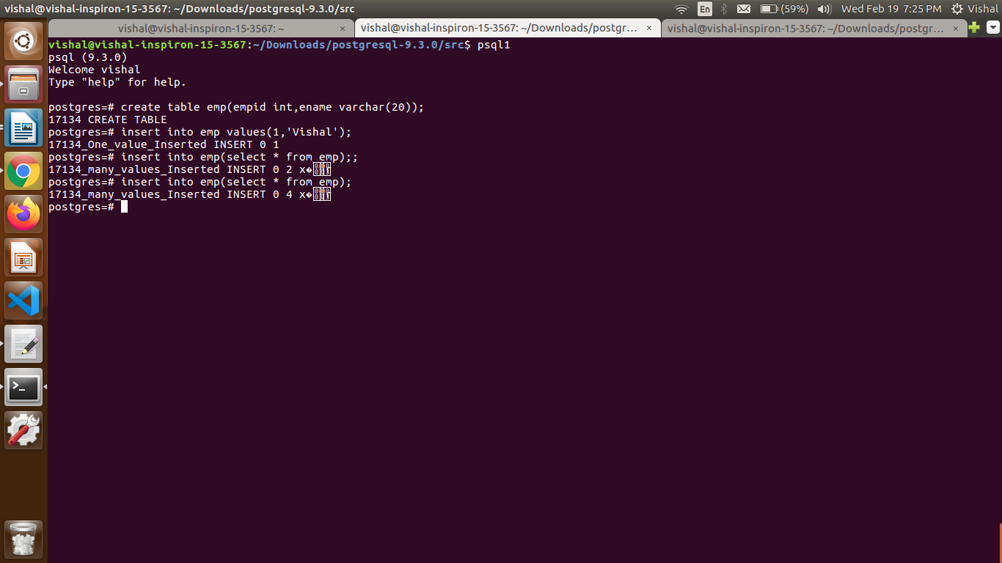
goto this function in src/backend/tcop/pquery.c file
static void
ProcessQuery (PlannedStmt * plan,
const char *sourceText,
ParamListInfo params, DestReceiver * dest, char *completionTag) function

change Insert->17134 Insert in both if and else statement.
Same for Update and alter table also
